Problem 12.1

1. counterexample shortest path from **A to C**

A answer: A->B->C weight=0

add large constant C to each edge

1 2 answer becomes A->C weight=C+2

B -1 C where weight of A->B->C is 2C

2. counterexample shortest path from **A to B**

A 10 B answer: A->D->C->A->B weight=9(if the cycle

-1 11 can only run once)

Run Dijkstra’s algorithm from A to B

C D answer becomes A -> B weight=10

-11

The above two counterexamples show these two methods all fail.

Problem 12.2

Meeting_Point.cpp

Problem 12.3

a)

if the puzzle matrix is like this: 1 1 1

1 1 1

2 1 1 then the corresponding graph will be like:

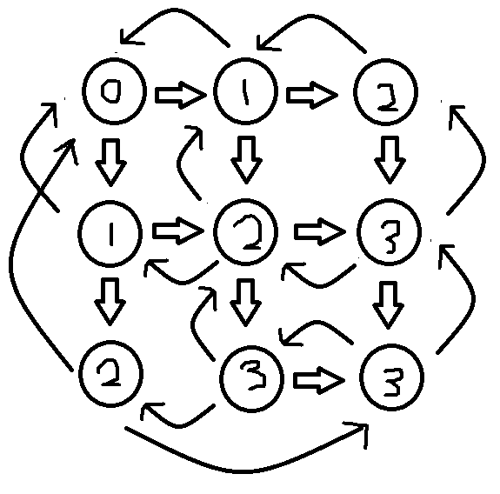

where every node has two directed edges(corner)

three directed edges(side), and

four directed edges(middle).

Also, the numbers of the nodes represent which level they are on from the top left corner node.

b)

Number_Maze.cpp